UK Timber Industry Associations’ Accord response to the consultation ‘Next steps to zero carbon homes: allowable solutions’

Summary of Response
As we move towards zero carbon buildings, the use of more sustainable materials is becoming increasingly important relative to the impacts of building energy consumption.
This Allowable Solutions consultation is an opportunity to emphasise rather than ignore the vital contribution that renewable materials can make. We are currently of the opinion that Embodied Impact reduction, which benefits the use of more sustainable materials such as timber, should become an Allowable Solution. We believe that a National Standard for Embodied Impacts should be developed following the Housing Standards Review consultation and that this should form the verification route for embodied carbon to be an allowable solution.
We welcome the inclusion of forestry solutions as an Allowable Solution. One element of the consultation is the geographic region in which this contribution should be made, and we suggest that focus here is on UK as part of a centrally managed strategy rather than local administration. Great strides are being made here as part of the Grown in Britain Initiative.

Suggested Outcome
As the operational carbon use in new buildings becomes less, the critical element in terms of the lifetime carbon ‘footprint’ of the building is the materials used to build them.
The included case study on timber windows indicates that if sustainably produced renewable materials are used within a product to build houses, and their embodied carbon is taken into account, the materials used will have a major effect in reducing the lifetime carbon ‘footprint’ for that building. It is the renewable and sustainable nature of the material which allows it to store the carbon both during the growing phase and then the use phase. The use of such materials is therefore one of the solutions for achieving zero carbon homes.
When considering the Allowable Solutions Criteria, use of renewable material should be offset against Allowable Solution contribution to reward sustainable choice (as per current waiving of the Merton Rule in areas like Hackney based on renewable choice).
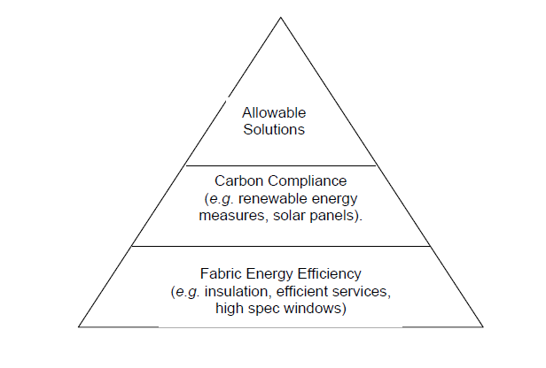
Renewables offset
We feel that the Housing Standards Review presents a unique opportunity to develop a ‘Nationally Described Standard’ for embodied impact. The publication of EN 15804 giving a harmonised method for assessing the environmental impact of products make it clear what embodied impact statements should embrace.
A working group should be established to consider a Nationally Described Standard for embodied impact.

Case Study: Timber Windows
Conducted within ISO 14040 and PAS2050 guidelines, using SimaPro 7.3.2 software and the Ecoinvent 2.2 database, the Heriot Watt report sets a new standard for the whole life cycle appraisal of windows demonstrating that timber window frames are the most environmentally friendly choice and offer the best value in normal conditions.
Energy is needed to create buildings through extraction and processing of raw materials, manufacture of finished products and components, during construction, to transport materials and products to site, to maintain components and to process materials at their end-of-life to recycle and/or dispose of materials this is accepted Life Cycle Assessment (LCA) thinking.
Global Warming Potential is a relative measure of how much heat a greenhouse gas traps in the Earth’s atmosphere. It is measured in Carbon Dioxide equivalency (CO2e).
Generally speaking a material, product or component has three main stages to its cradle to grave carbon lifecycle; Embodied Carbon (EC), Operational Carbon (OC) and End of Life carbon (EoL). In the case of windows, maintenance is captured under the operational energy stage.
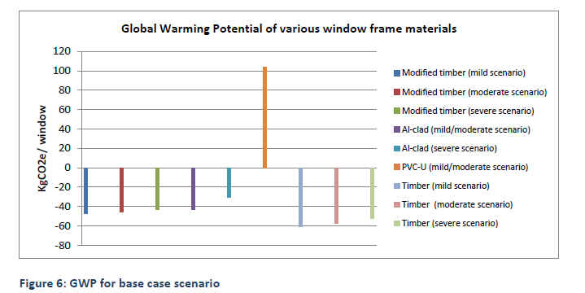
Timber based window options have negative values due to the carbon storage effect of timber during its growth phase. This is the case for all End of Life assumptions (base case based assumes current EoL treatments for the various frame materials endures) and providing timber is sustainably sourced. The conclusion is that using a timber window frame instead of PVC-U saves roughly 160kgs CO2e over 60 Years in average conditions. In a house with 10 windows, that’s over 1.5 Tonnes CO2e.
This information is currently being applied to the Green Guide to update the current timber window frame ratings. This information can be applied, using EN15804 methodology, to produce Environmental Profile Certificates (EPCs) for products, which is then fed into IMPACT and BIM datasets.
The above logic can now easily be applied to all products, for example the use of timber joist or wood based panels, and we should be seeking to capitalise on and reward sustainable/renewable choices.
Matt Mahony, British Woodworking Federation Policy Executive, on behalf of the UK Timber Industry Associations’ Accord

The UK Timber Industry Associations’ Accord
There are 14 signatories to the Timber Industry Accord. From windows to Roof trusses, a wide variety of wood and wood products are represented.

British Woodworking Federation
Confor
Glued Laminated Timber Association
Structural Timber Association
Timber Packaging and Pallet Confederation
Timber Research and Development Association
Timber Trade Federation
Trussed Rafter Association
UK Forest Products Association
UK SIP Association
Wood for Good
Wood Panel Industries Federation
Wood Protection Association & Timber Cladding and Decking Association
Wood Window Alliance

Grown In Britain Campaign: http://www.growninbritain.org/
Life Cycle Assessment of timber, modified timber and aluminium-clad timber windows: http://woodwindowalliance.com/medialibrary/uploads/Documents/pdf/Final%20report%20SLP%20WLC%20and%20LCA.pdf

