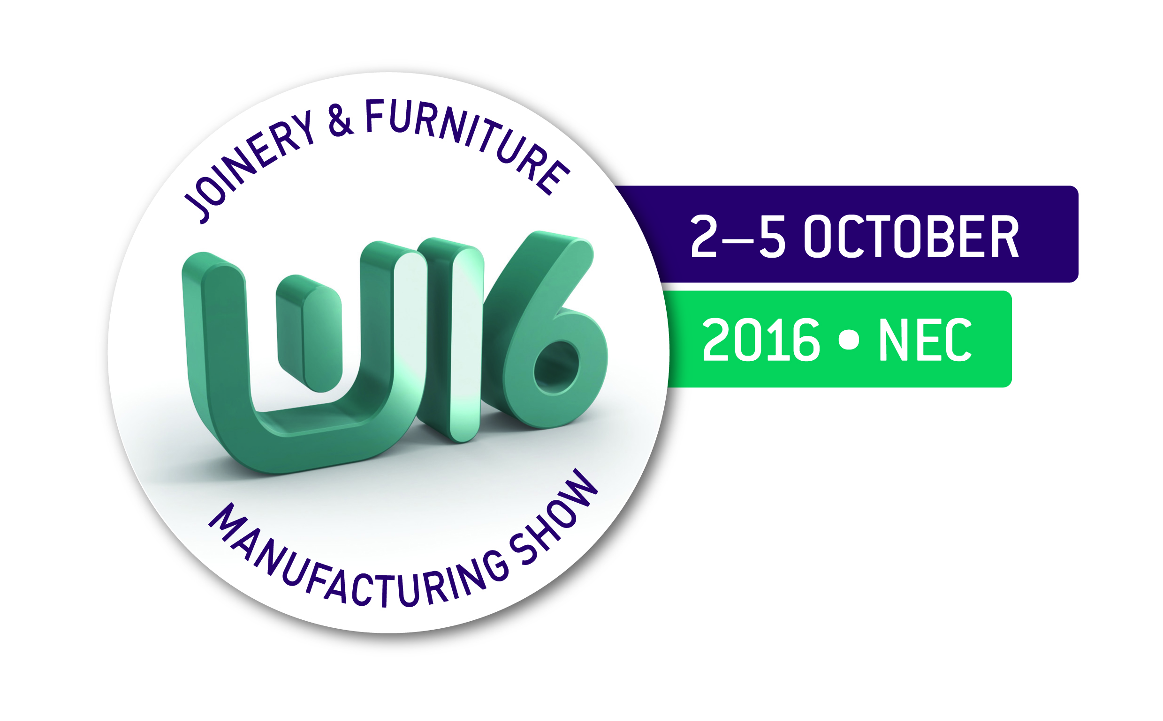
BWF Process Efficiency Award 2016
APPLICATION FORM

Entry Rules

- Entries are invited for clear thinking, measureable results, commitment and adding value to your business by the introduction of lean processes. Lean processes are those focused on providing customers with the best possible products at the best possible prices, at the best possible quality levels and at the best possible delivery times.
- You can submit an entry for an individual, company or project/initiative
- Entries are limited up to two per company regardless of category
- Nominations can be made directly by the individual or company, or you can nominate another individual or company
- Previous winners cannot submit another application where the nature of the innovation or excellence is the same as the previous entry.
- Applications must be received by no later than Friday 24th June 2016, 5pm
- There is no entry fee
- BWF cannot accept any responsibility for the loss or damage to entries
- Judges’ decisions are final and no correspondence or discussion will be entered into regarding the selection process

Judging Criteria

You can enter the award for:

- The company as a whole
- An individual for their specific contribution/leadership
- A specific initiative undertaken by the company

The award will be judged against any of the following criteria:

- Clear thinking – A solution to a clearly defined and well understood problem
- Measureable results – measured evidence that efficiencies have been made
- Commitment – Clear methodology and a well managed process
- Adding value – Demonstrating a contribution to bottom line results

Entry Requirements

To enter, simply send the following:
- No more than 500 words about the initiative/company/individual that shows how the entry meets the judging criteria
- Other supporting documentation or financials which outline the process efficiencies made
- Photographs (in a digital format, jpeg format) if available.

Awards Presentation

The Award will be presented at the BWF Annual Dinner & Awards on the evening of Tuesday 4th October 2016 at the prestigious Motor Cycle Museum, Birmingham.
Up to three shortlisted entries will be notified of their success at least one month in advance, and they will be invited to the Annual awards on 4th October 2016 free of charge (one complementary ticket). Additional tickets to the Dinner & Awards are chargeable and only £95+VAT.

Sponsorship Information
The Process Efficiency Award is Kindly Sponsored by
Entry form

Please complete the below and return this entry form together with your supporting evidence to:

Email Dave Campbell, Membership & Training Director, at: dave.campbell@bwf.org.uk

--OR--

BWF Award 2016, British Woodworking Federation, The Building Centre, 26 Store Street, London WC1E 7BT
(please note that images will still need to be provided in an electronic format)

1. Company or Initiative Entry

Please enter the details of the company/initiative you wish to nominate for this award:

Company: ________________________________ ________________________
Initiative Title (if applicable): ___________________________________________
Address: ______________________ __________________________________
____________________________ ___________________________________
Contact Name: ______________________________________________________
Job Title: ___________________________________________________________
Contact Tel No: ______________________________________________________
Contact Email Address: ________________________________________________

If you are NOT from the company being nominated, please fill in your details:
Full Name: __________________________________________________________
Job Title: ___________________________________________________________
Company (if different from above): ______________________________________
Address (if different from above): _______________________________________
_________________________________________________________ _________
Contact Tel No: ______________________________________________________
Contact Email Address: ________________________________________________

2. Supporting Evidence
In no more that 500 words, please explain why you have nominated the initiative, individual, or company for the Process Efficiency Award:
Can be provided in electronic form separately

Please forward any additional documentation, financials or photographs separately to this form.

